CSE Assignment 4

1 Explain about call by value and call by reference with

suitable examples. 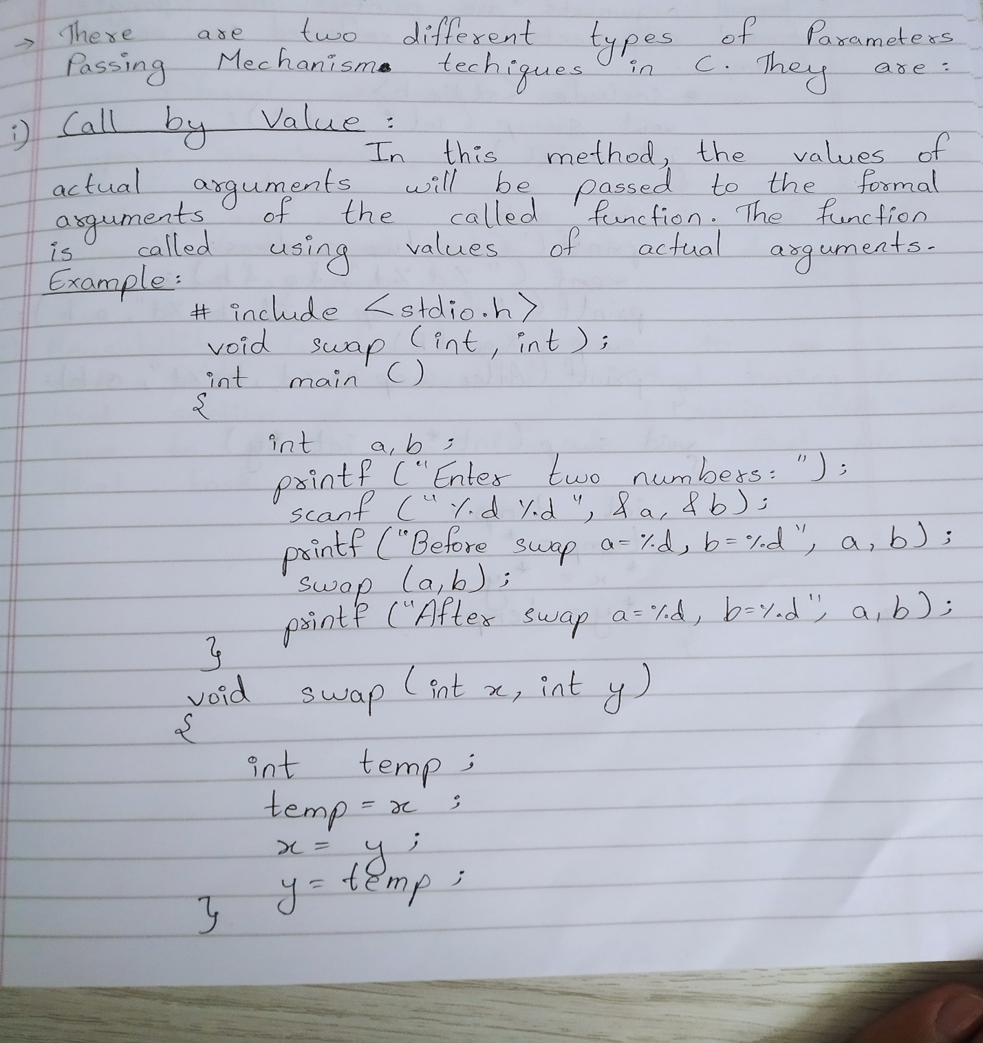

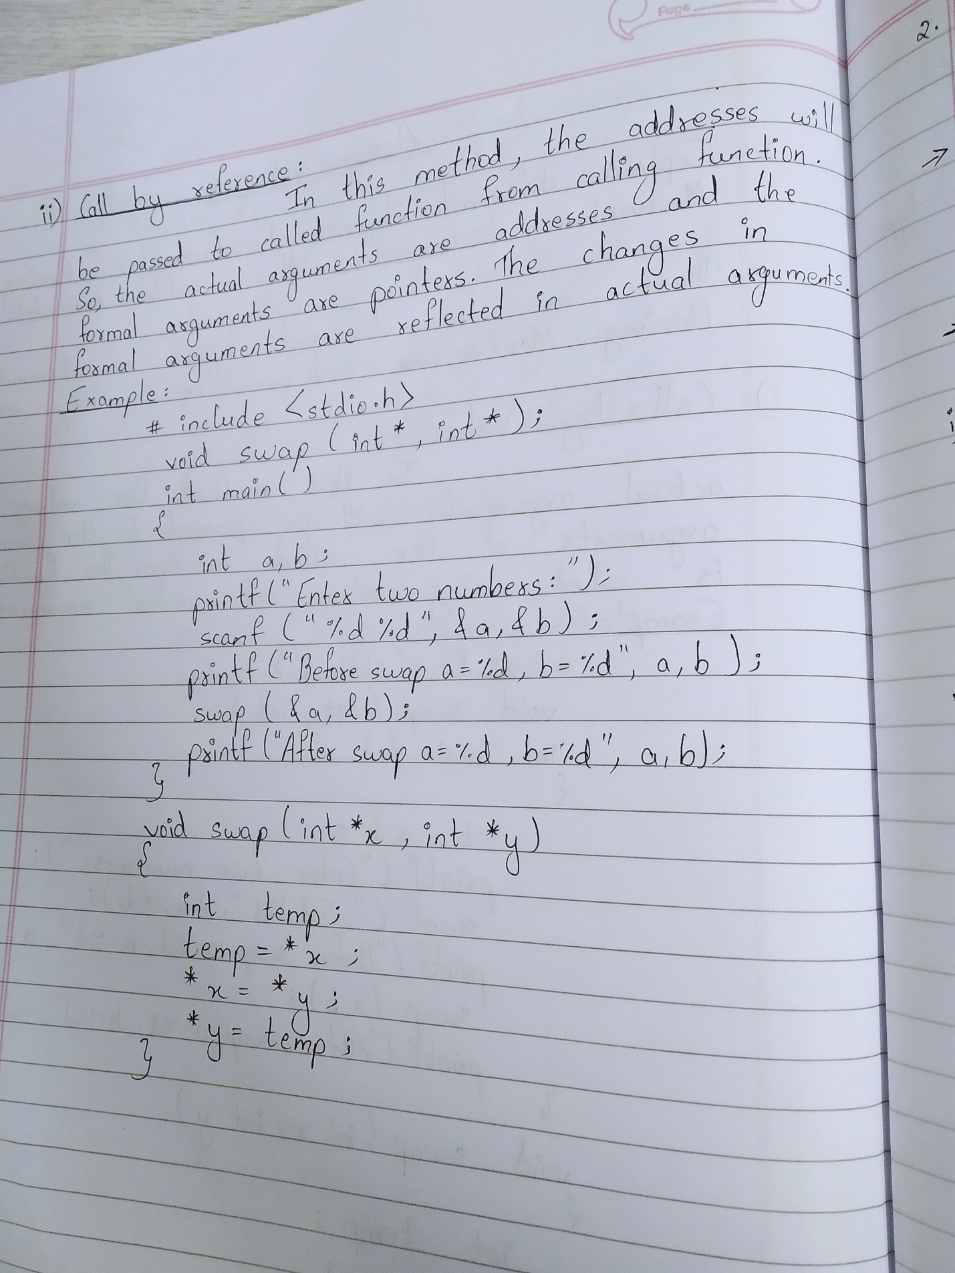

2 Write a C programme for Multiplication of two matrixes.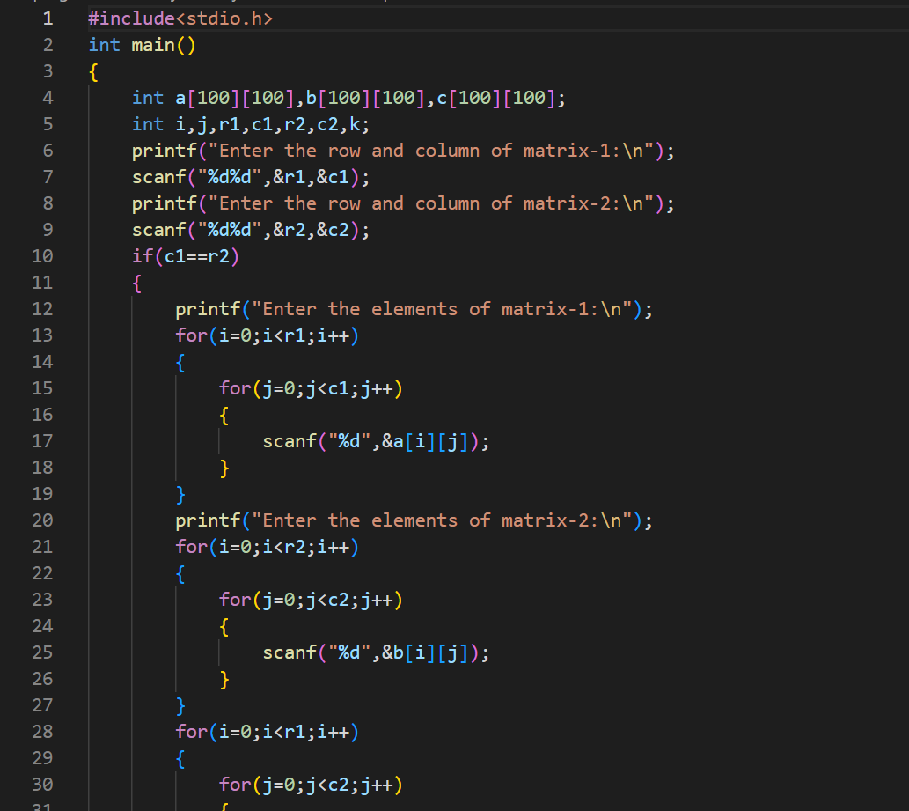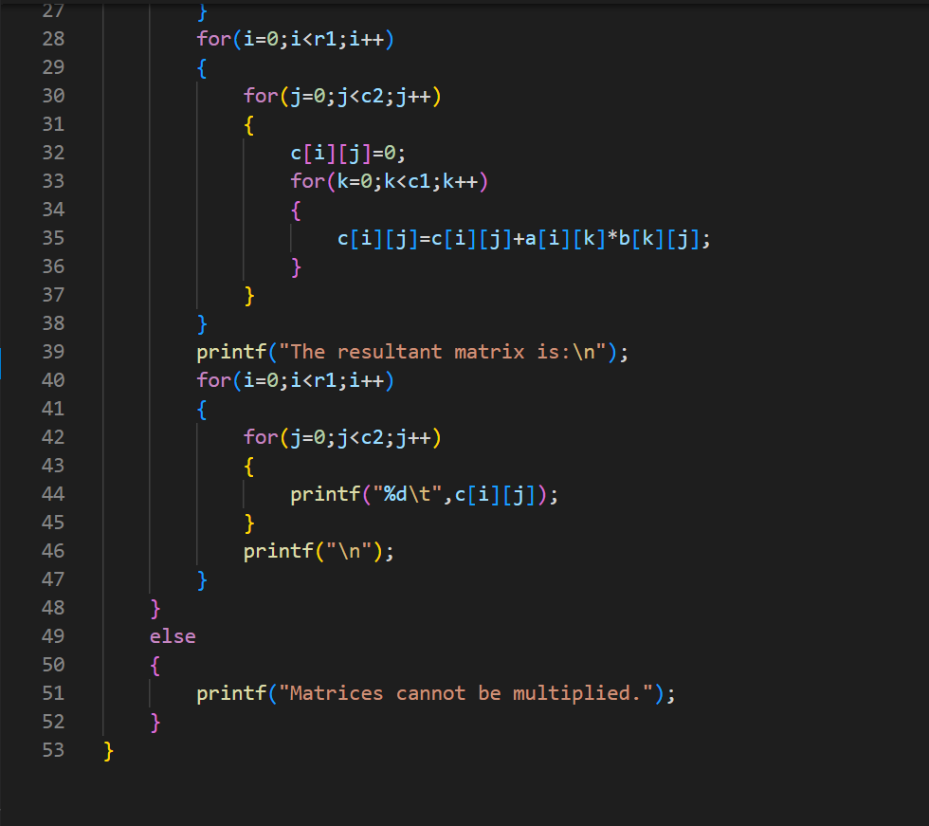

3 Write a C programme to implement Fibonacci series

using recursion.

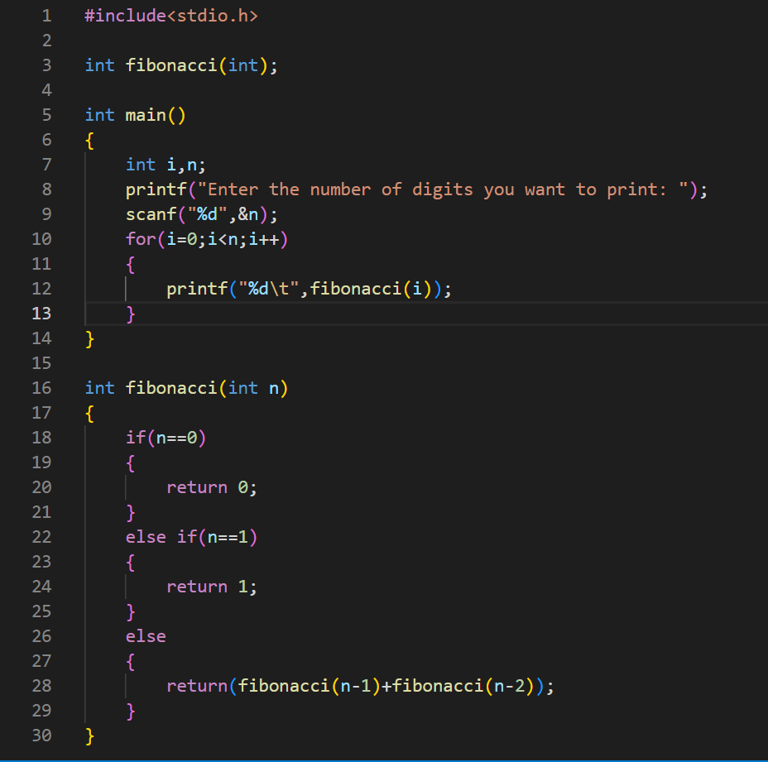

4 Explain about String handling functions?

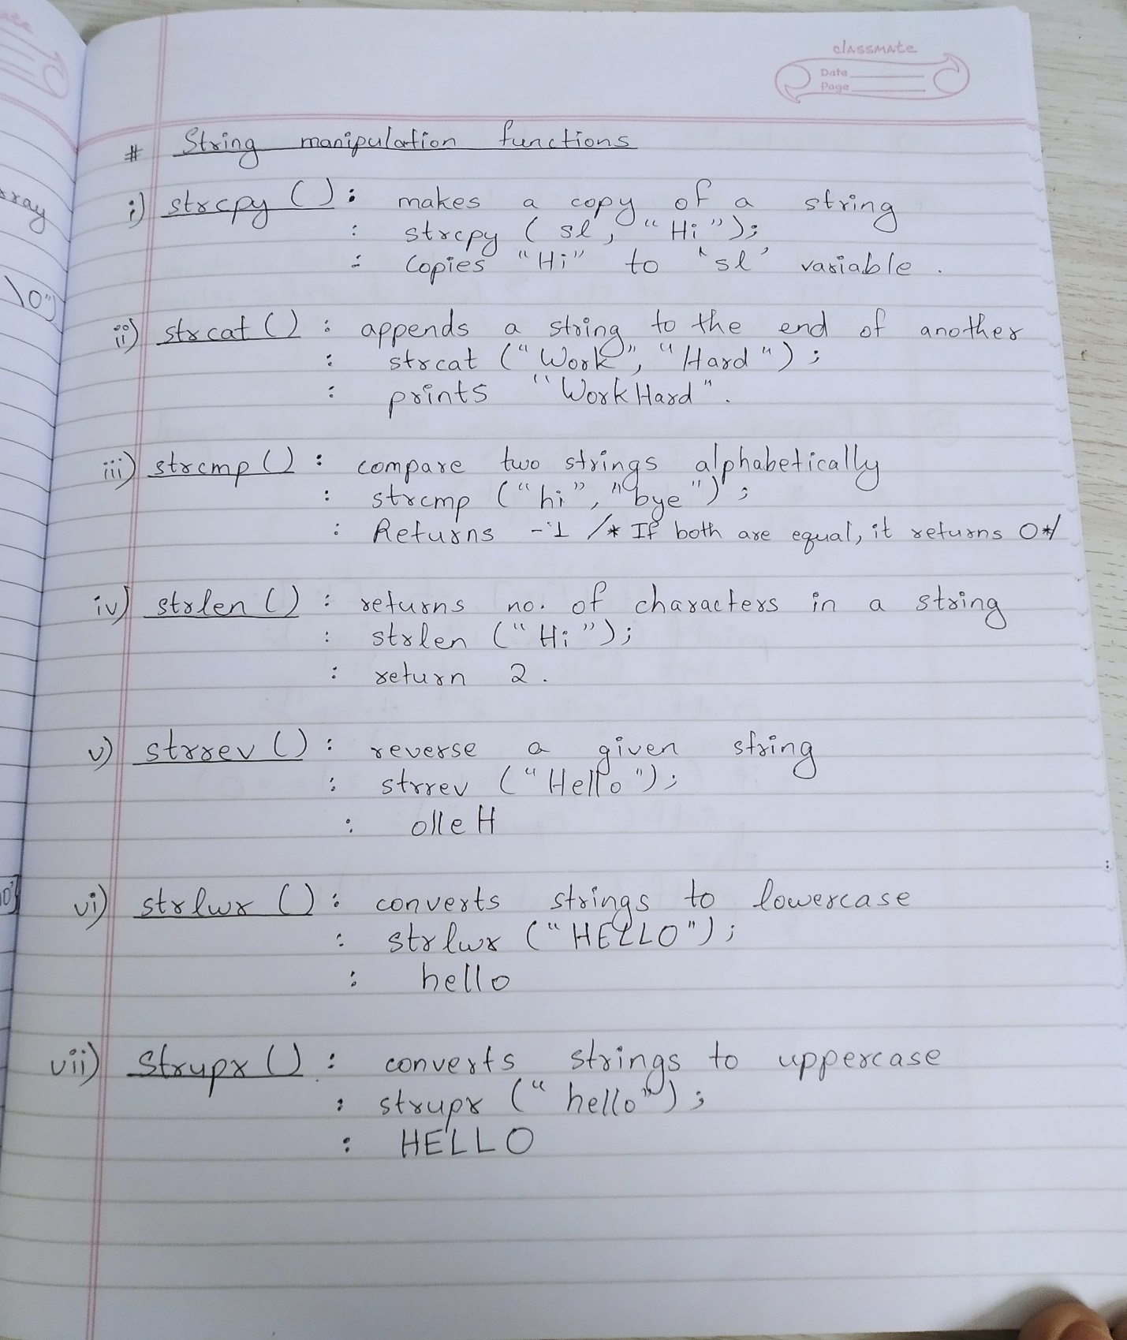

5 Write a C programmes to sort the given set of strings.

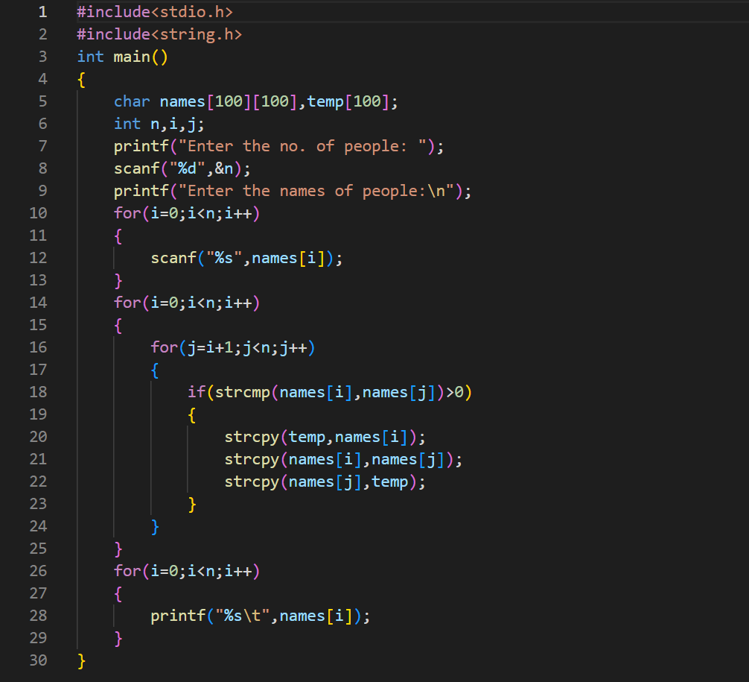

6 What do u mean by a function? Give the structure of

user defined function and explain about the

arguments and return values.

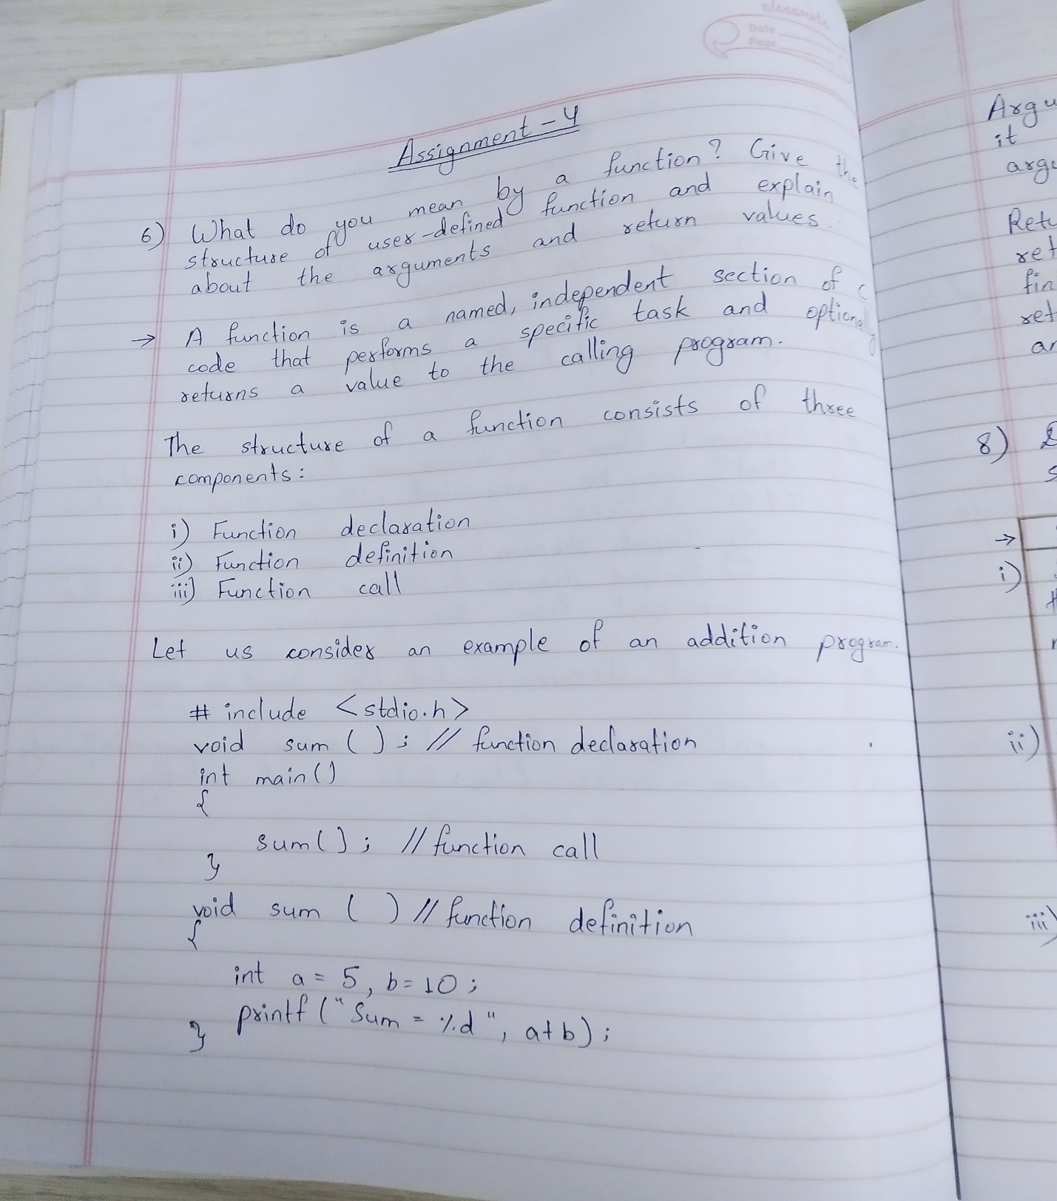

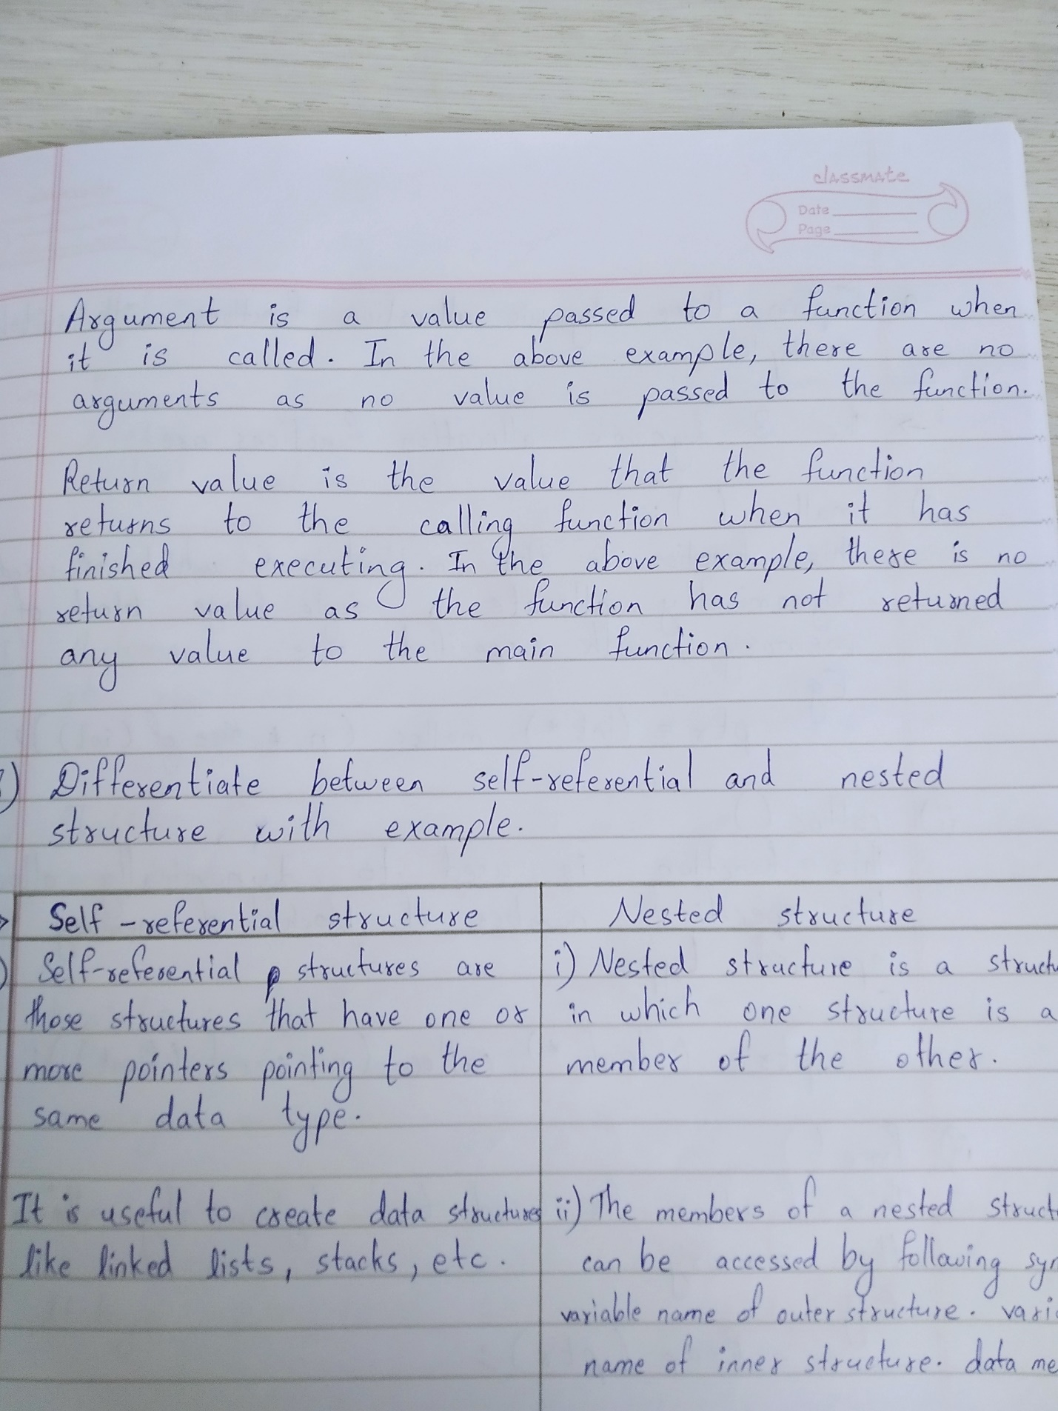

7 Write a programme to read, calculate average and

print student marks using array of structures. 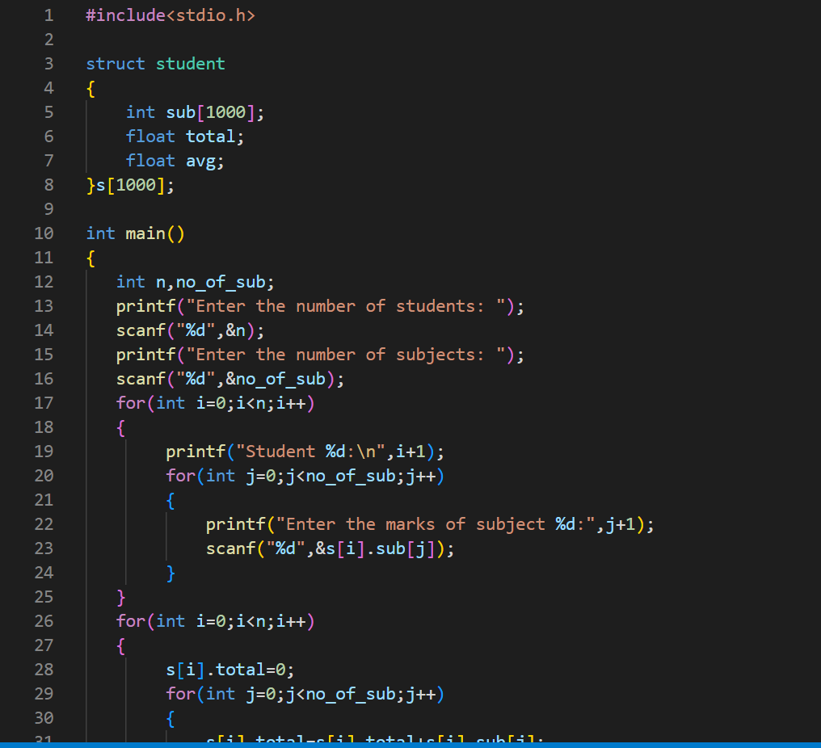

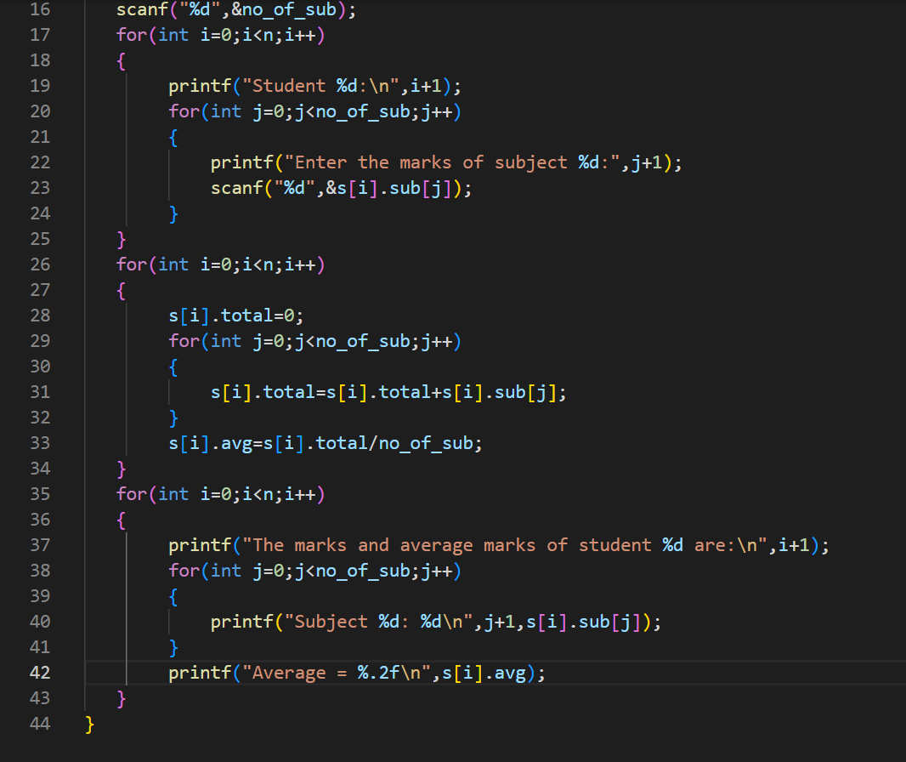

8 Differentiate between self-referential structure and

nested structure with example.

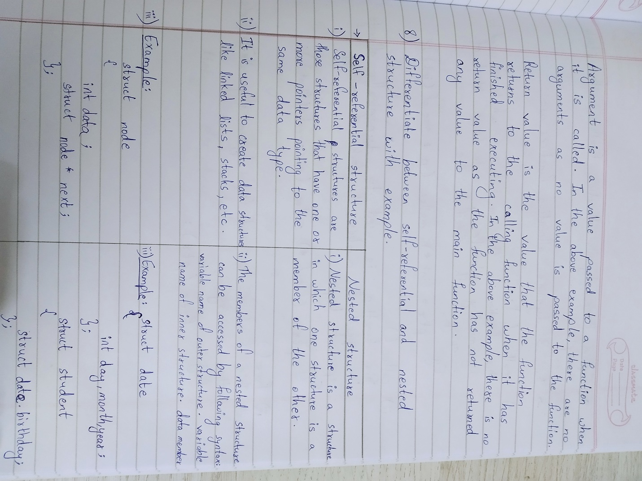

9 Explain three dynamic memory allocation functions

with suitable examples.

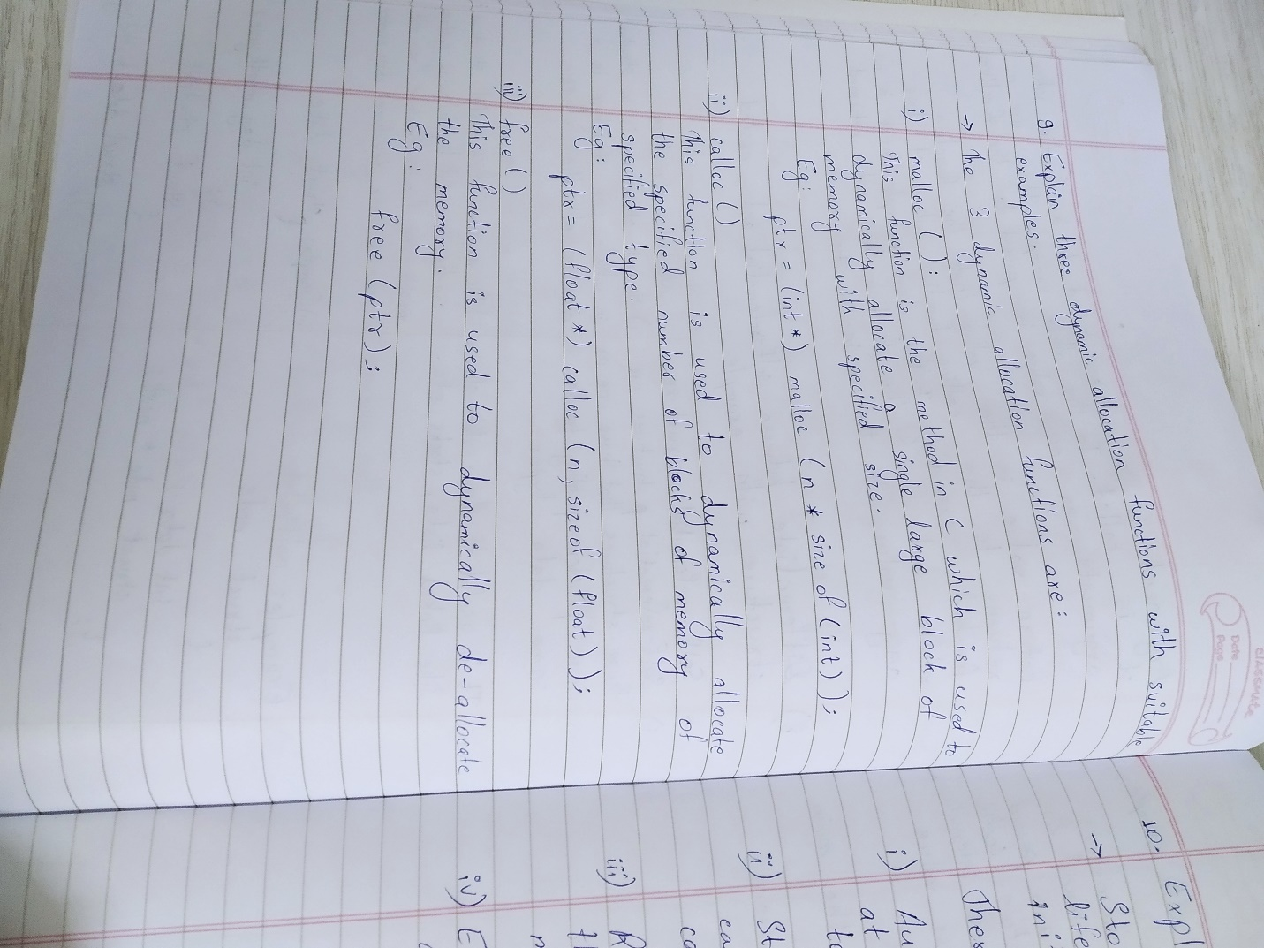

10 Explain about storage classes.

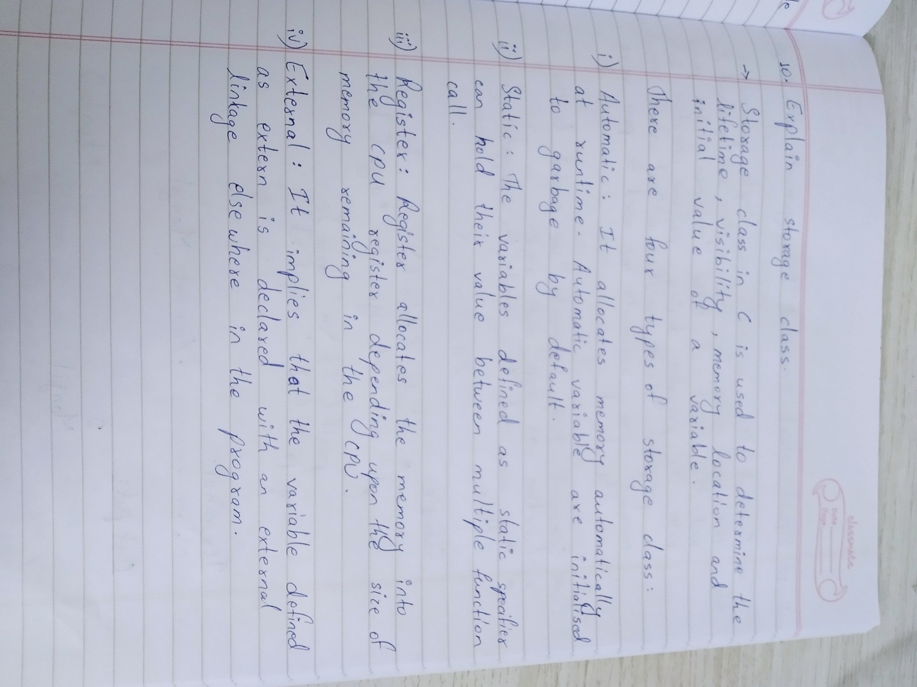

11 Develop a programme to create a library catalogue

with the following members: access number, authors

name, title of the book, year of publication and book

price using structures. 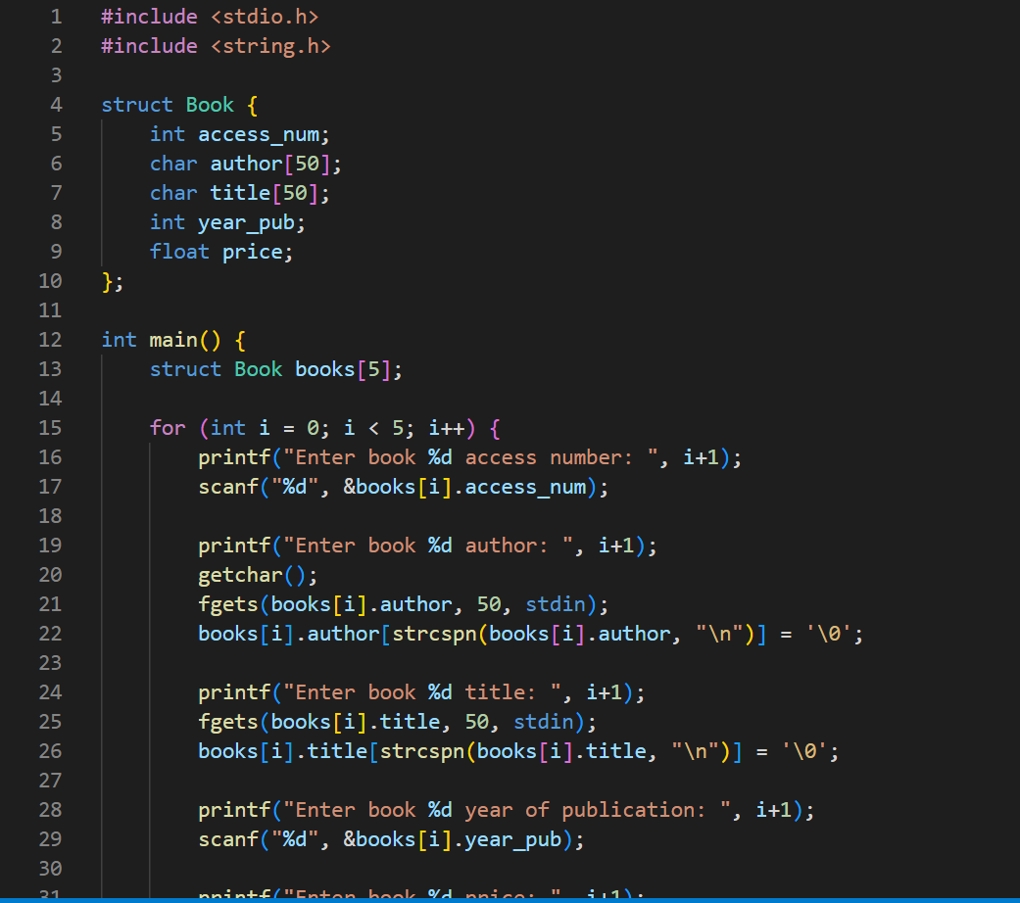

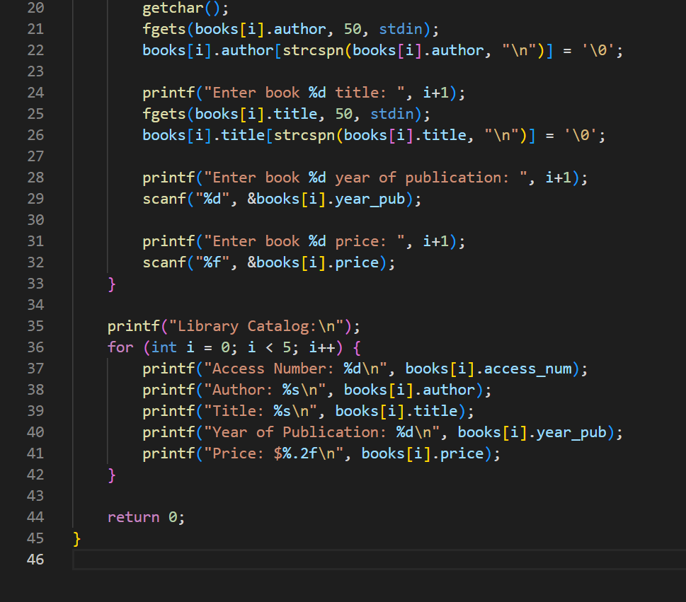

12 Explain about command line arguments with an

example.

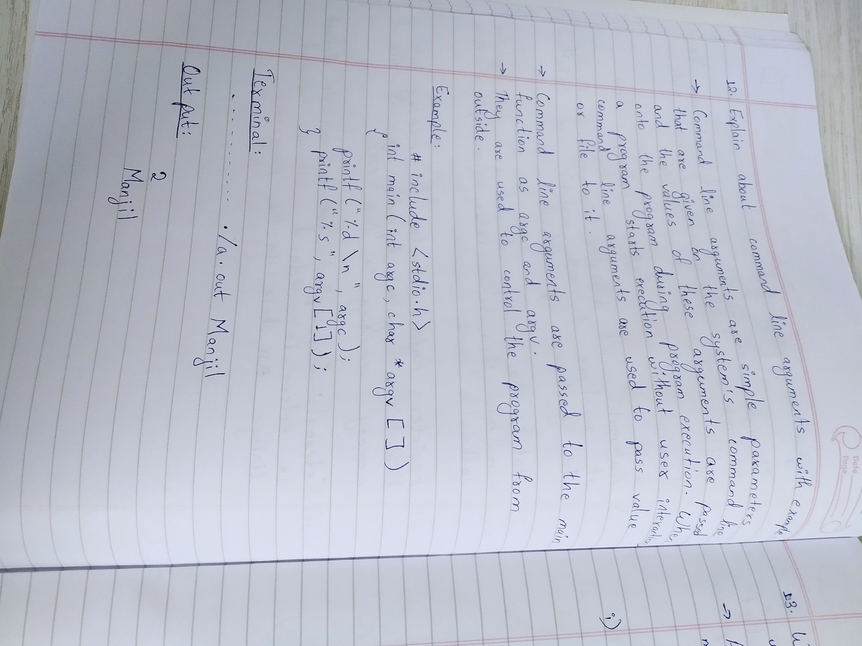

13 What is a Pointer? Explain pointer arithmetic

operations with suitable examples. 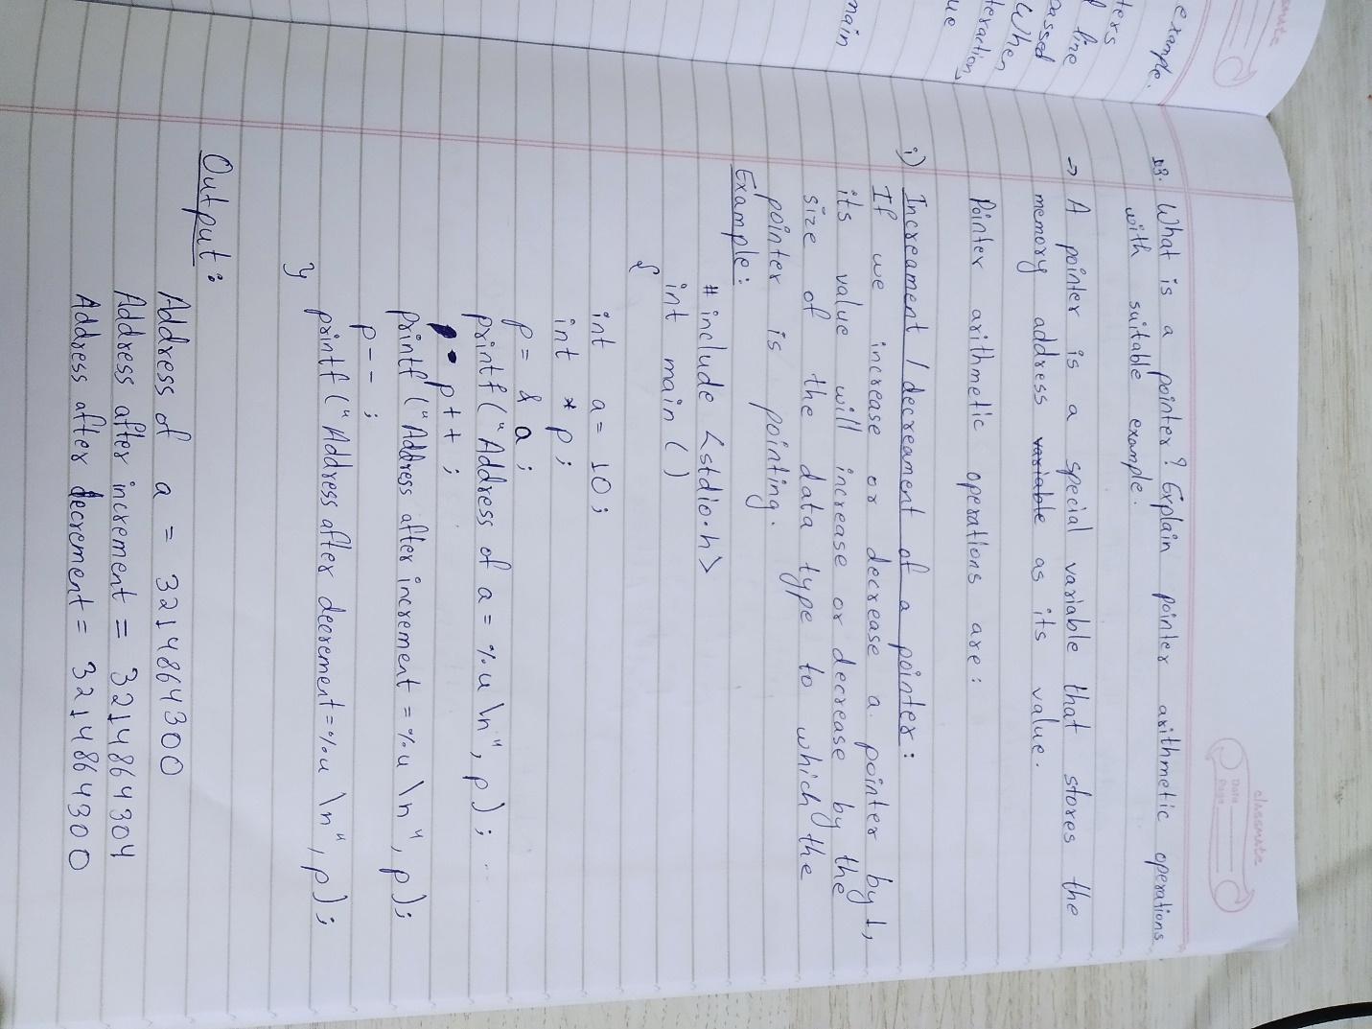

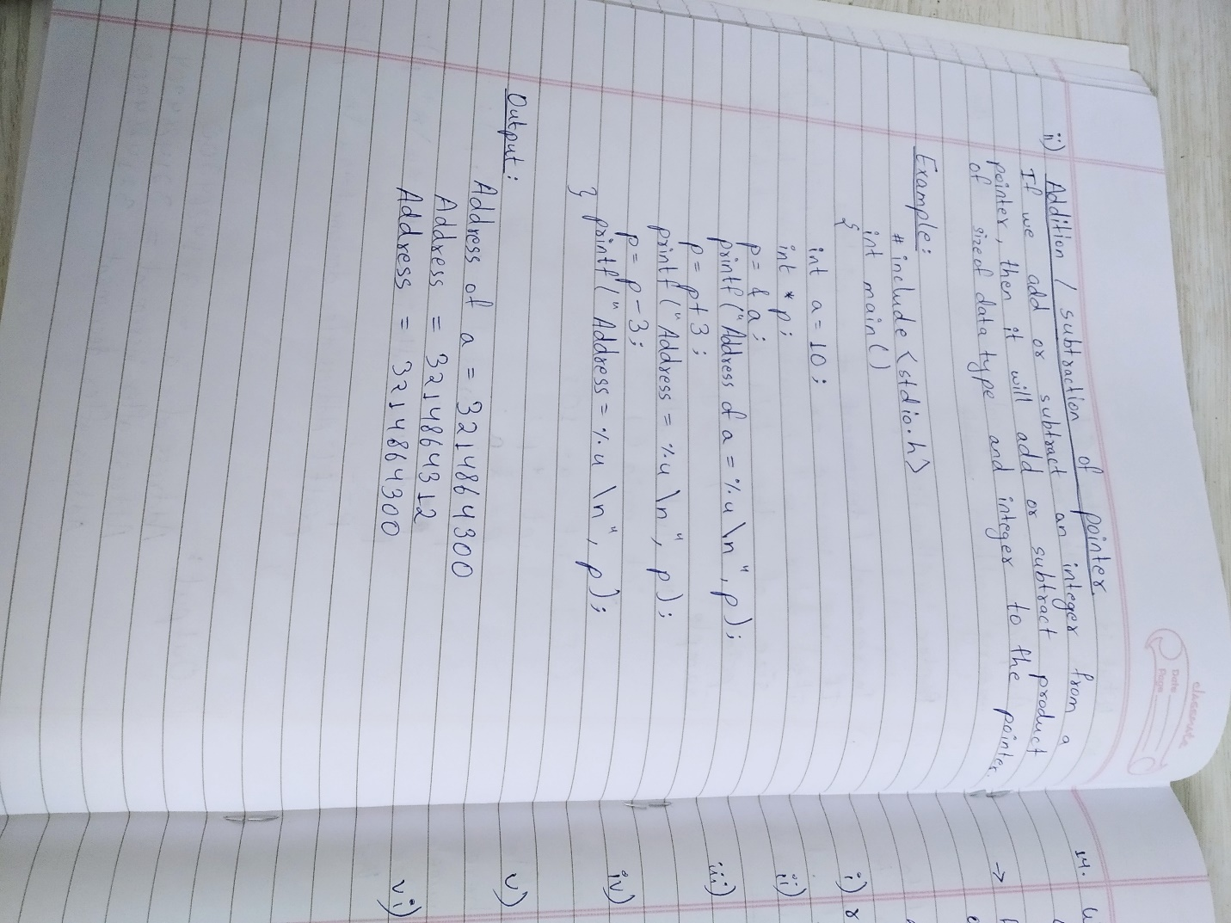

14 What is a file? Explain different modes of opening a

file.

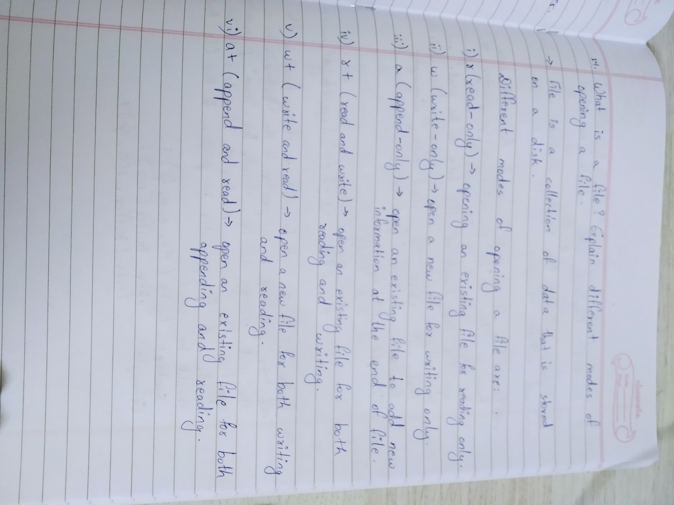

15 Write a programme to demonstrate read and write

operations on a file.

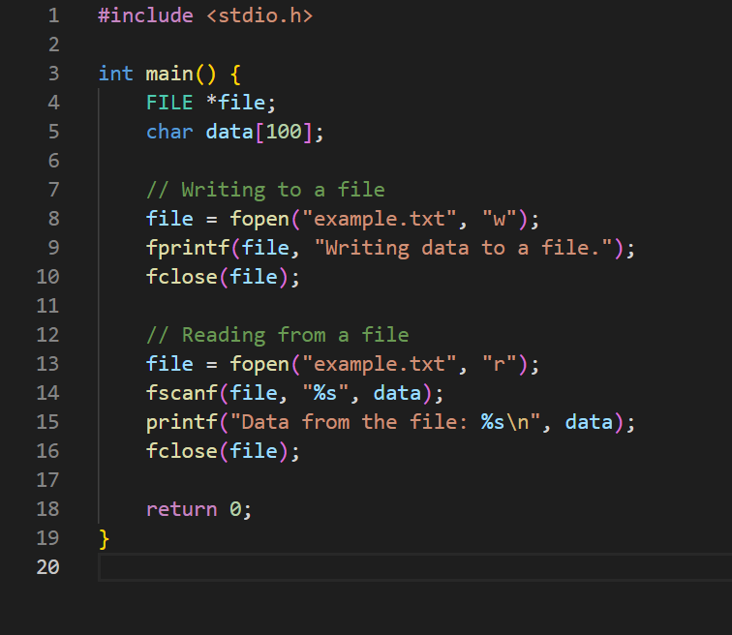

16 Explain about fscanf(),fgets(),fprintf() and fwrite()

functions with suitable examples.

AND

18 Explain different file handling functions with syntaxes

and suitable examples. 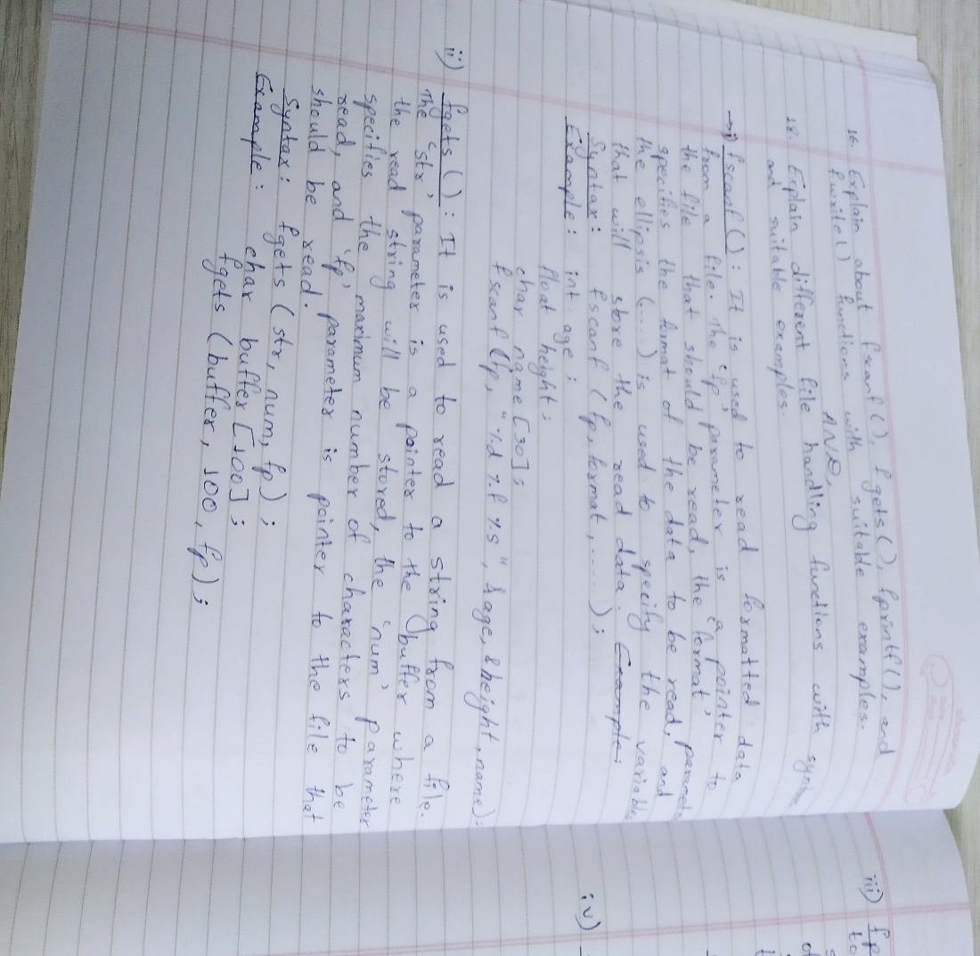

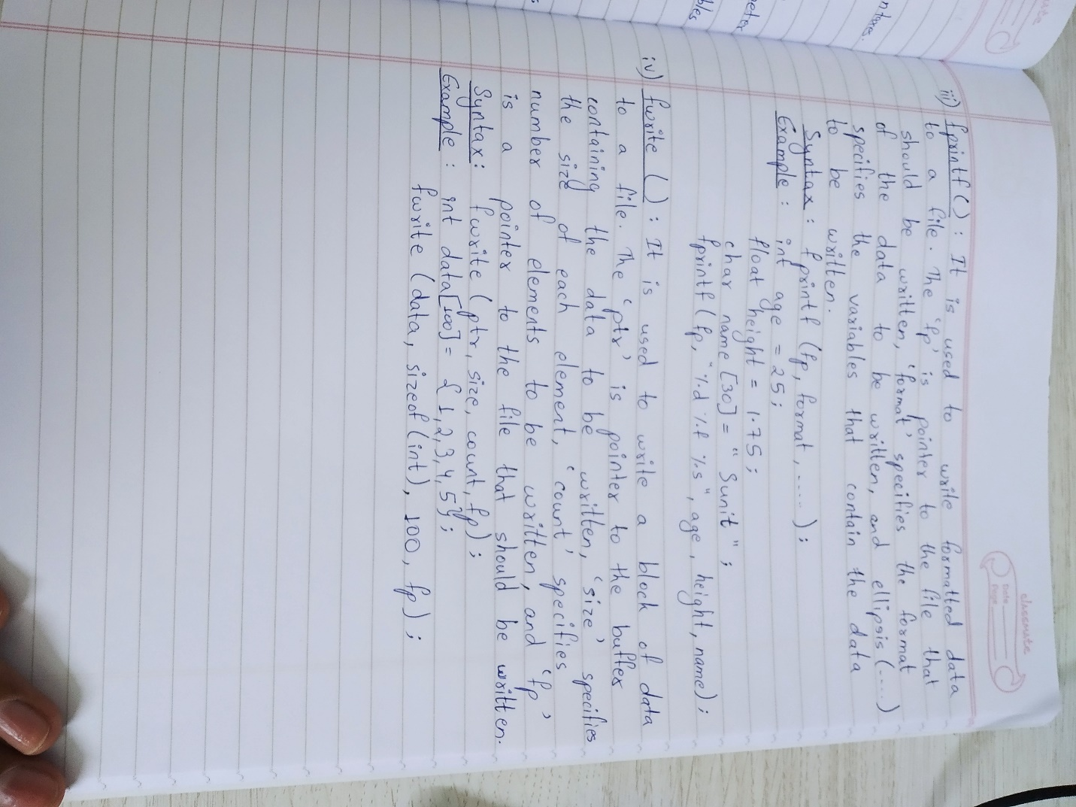

17 Write a programme to copy one file contents to

another.

